


Manager (Approver)/Timekeeper User Guide

Revised 4/12/2023

Table of Contents
Contents
Logging In to TCP 4
Your Dashboard 5
The Side Menu 6
Tools 6
Request Manager 6
To enter a leave request for an employee 8
To cancel a request for an employee 9
Employee Status 9
Reports 10
Hours 11
Individual Hours 11
Group Hours 13
Approvals 15

Logging In to TCP

Manager/Approver Access – The link to the system is located on the Employee Resources page of the KRESA website. This is a Single Sign-on link so if you plan on bookmarking the page, be sure to copy the link itself not the page that appears after you log in. The website does timeout so be sure to save any changes you make frequently.



Direct Link: https://myapps.microsoft.com/signin/3a266d75-506d-4ca3-8c08-651a7c582305?tenantId=db41661a-e1af-4c7c-aa1d-bebeb98a9be7

Your Dashboard
Widgets can be customized
Click Edit 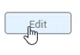 in the upper right.

You can drag and drop to reposition widgets.
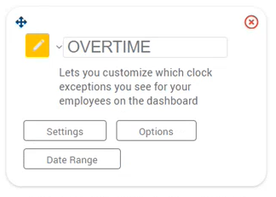

And adjust Settings, Options and Date Range for each:

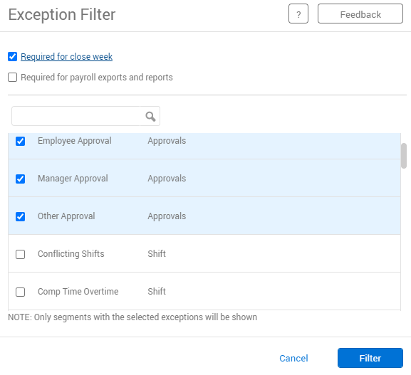

The Widgets have reports driving them; you can change the parameters of the reports by clicking Settings; scroll through the list, check mark the ones you want, and click Filter:

The Side Menu

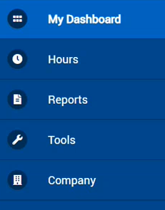
Company is where you will see Holidays; this is view only

Tools
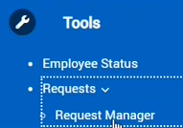

Request Manager
This is where you will review and act upon employee leave requests. This calendar view is the default, but you can switch to a list view: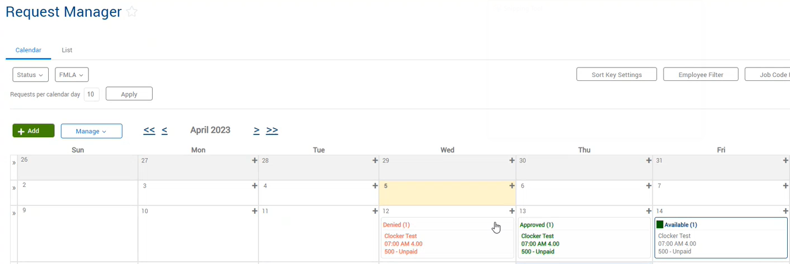
Red is denied, Green is approved, Blue needs attention.
Sample of List view:
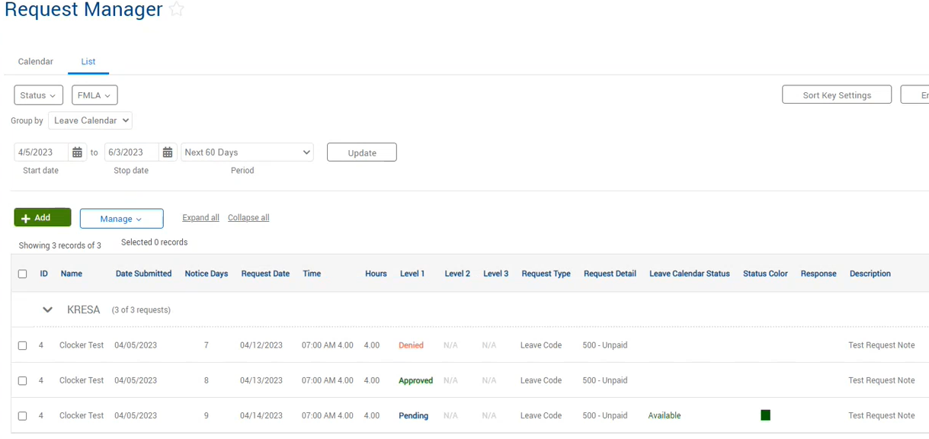

Double click on a time off request, or Right click and select Go to Detail to view the detail. 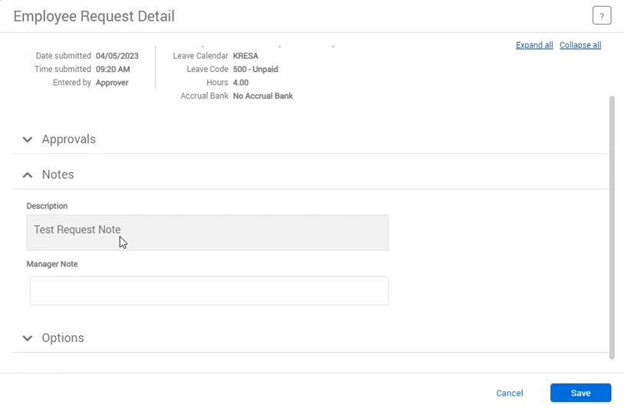
If there is a bank associated with the leave type, you will see a View Accruals button.
You can expand the Notes by clicking the arrow to see any notes entered by the employee.
You can also enter your own note; this note is not visible to the employee.
In this example, the employee “Clocker Test” is requesting 4 hours of leave starting at 7 AM using the 500- Unpaid code.
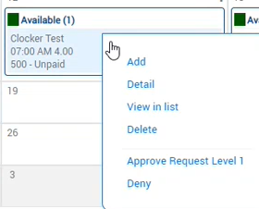

To act on this request, Right click then select from the options.

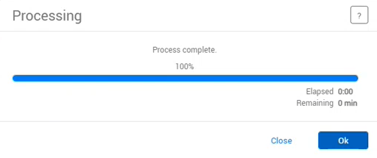
You will get a Processing progress window:

Click OK.

The employee will get an email letting them know that you have approved or denied their request.
When a leave request is approved, the system places it on the employee’s timesheet and reduces the associated bank.
NOTE: Once a leave request is approved, the employee cannot cancel it; they will come to you for assistance with this. Corrections to time and leave must be made within the pay period.

To enter a leave request for an employee

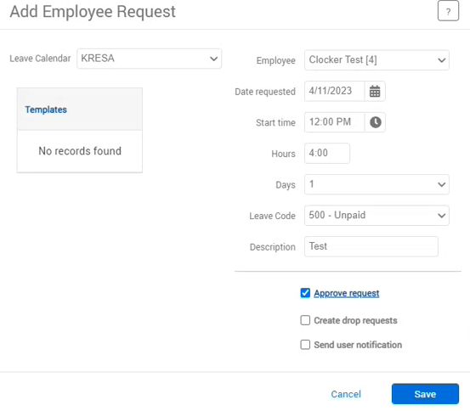
Click the button and fill in the leave detail:
Include the am/pm when entering time,

You can approve at this point by checking the box,

Then click Save.

To cancel a request for an employee
Right click on the request from the calendar or list view.
Choose Delete. You will get a warning box, click OK.
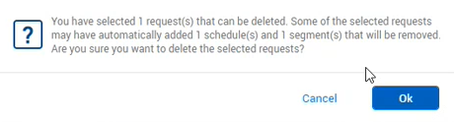
The leave hours will be put back in the employee's bank, and the request removed from their timesheet.

Employee Status
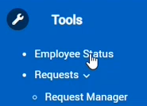
This shows the status of your CLOCKING employees:
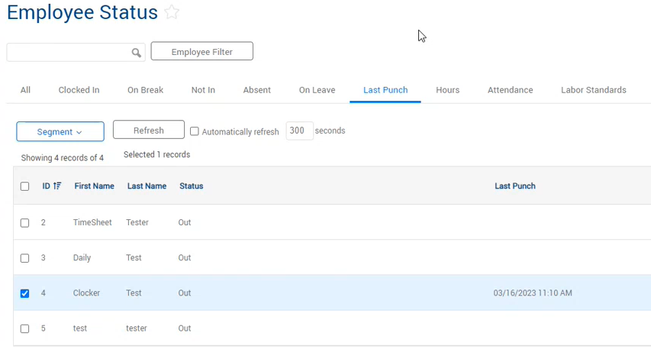
You can click the tabs across the top of the window to filter out employees; for example, if you want to see who’d on break, click the On Break tab.

Reports
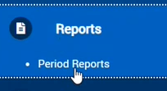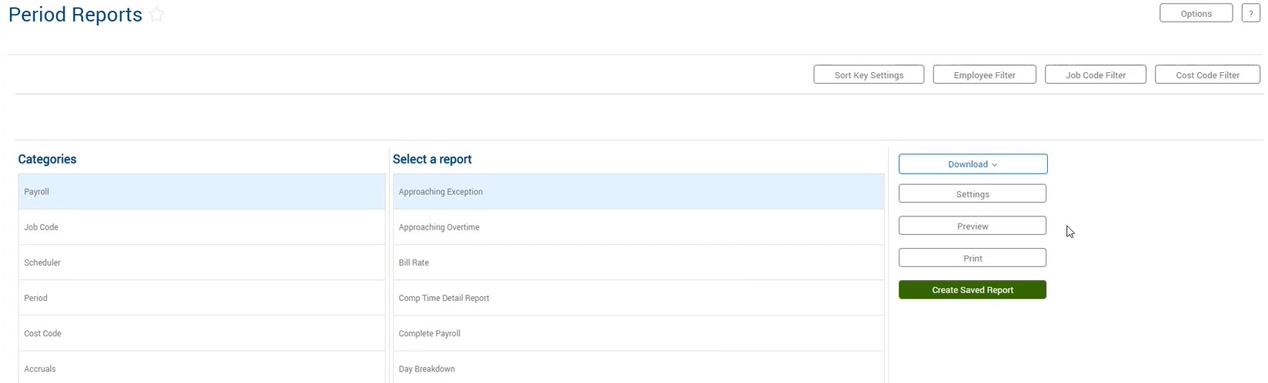
You have built in reports to choose from, click settings to customize the report to your needs.
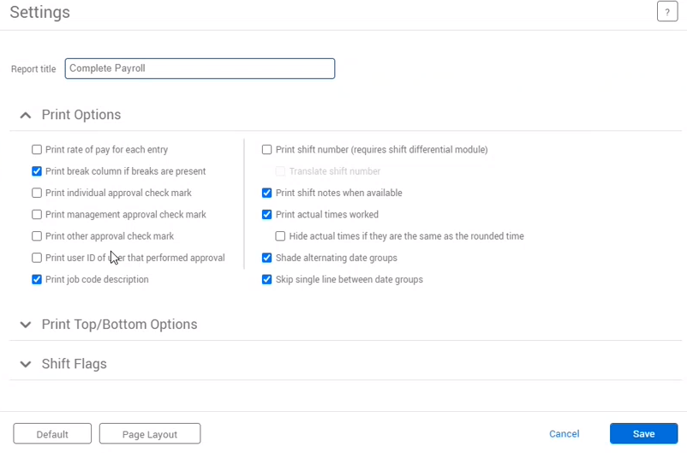
Click 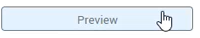to view the report in your browser before downloading or printing.

Hours
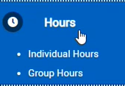

Individual Hours
Select the desired employee from the list on the left.
NOTE: When adjusting a date/range anywhere in TCP you must click 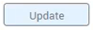 to see the new dates.
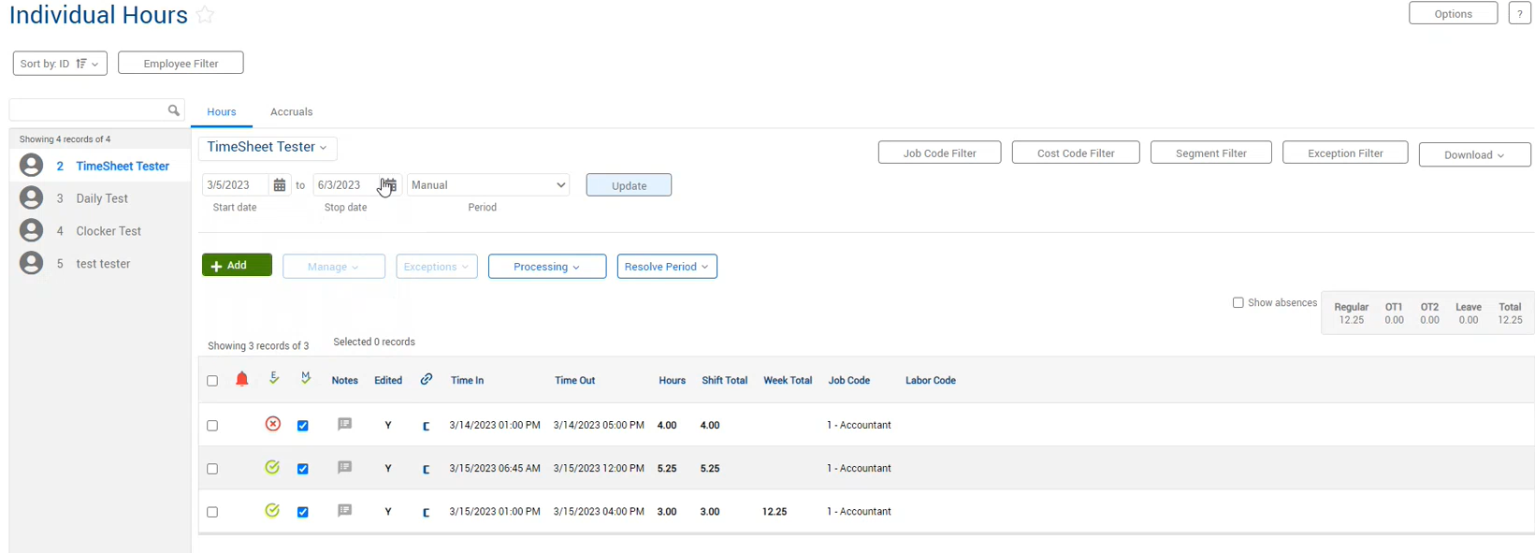
NOTE: Hours are displayed in hundredths format, 12.25 is not 12 hours and 25 minutes, it is 12 hours and 15 minutes.
Here is a link to a conversion chart: https://www.labor.nc.gov/workplace-rights/employer-responsibilities/time-conversion-chart-minutes-decimal-hours
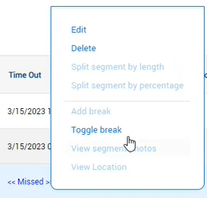
In this view you can easily see missed punches for clocking employees. To correct a missed punch, either double click on the segment, or right click and choose Edit.
You can also Delete a segment from here.
USE CAUTION WHEN DELETING, the recovery window is small.

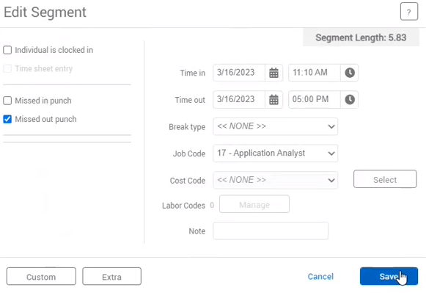
Make necessary changes and click Save.

Corrected segment will now appear Green. 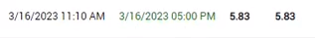

NOTES:
It is best practice to enter a note when adjusting an employee’s time. Simply click the dialog box 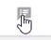 to enter a note for a segment.
The system captures the date and time a note was entered and the individual entering the note. Self means the employee entered the note.
The dialog box turns blue when a note has been entered.
You can add time or a leave request for an employee 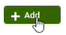
Enter all relevant data, then click Save.
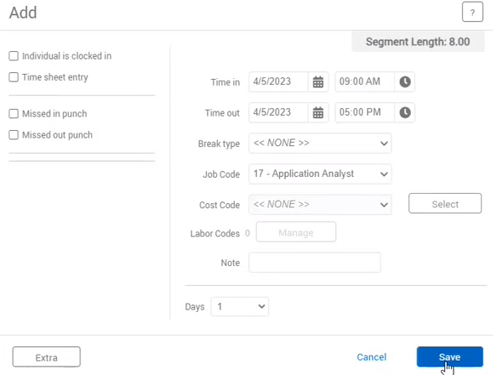

NOTE: you can only Add, Edit and Delete hours or leave in the current pay period and into the future.

Group Hours
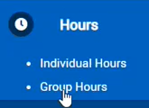 Adjust the date range as needed and click 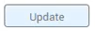to see timesheets for all of your employees:
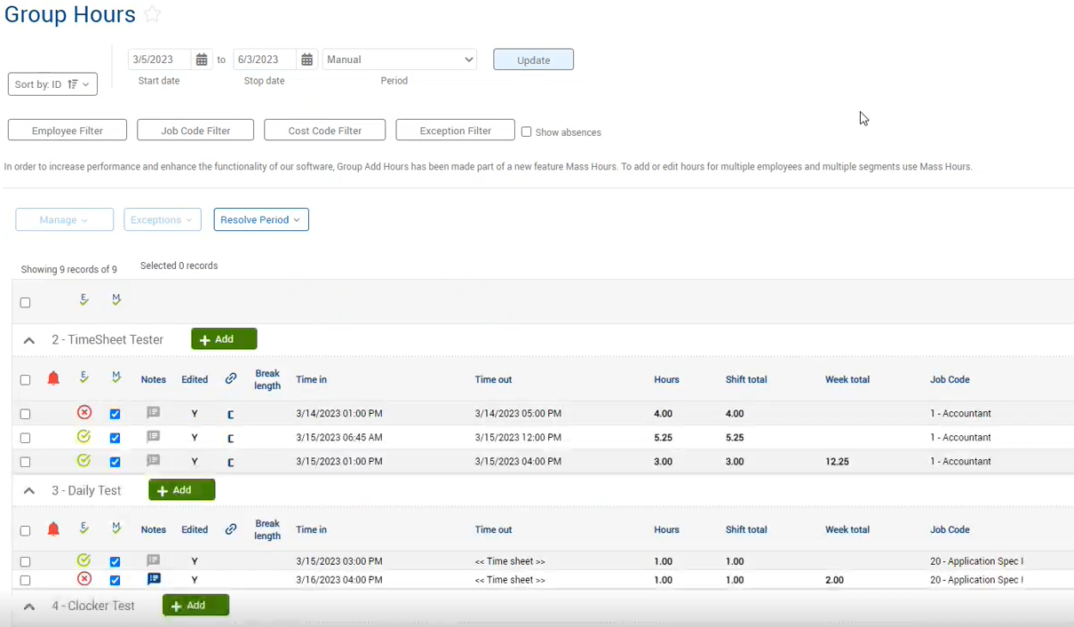
You can perform all of the same functions in the Group Hours window as you can in the Individual Hours window.
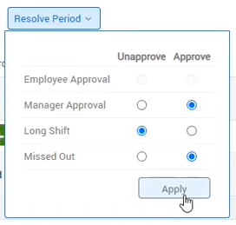

After (and only after) you have reviewed time for each employee, you can mass approve by selecting Resolve Period

Click in the Approve column under Manager Approval.

Then click Apply.
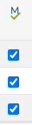

The entire Manager approval column will now have checkmarks in the boxes.

Approvals
Timesheets must be approved in order for them to be processed for pay.
We recommend approving timesheets weekly.

